

**EVALUATION OF INTERNSHIP REPORT**

## B.Tech: III Year

**Department of Computer Science & Information Technology**

**Name of the Student :- Gourav Chouhan**

**Branch & section :-CSIT-2**

**Roll No:-0827CI201069**

**Year:- 2022-23**

## Department of Computer Science & Information Technology

**AITR, Indore**

**ACROPOLIS INSTITUTE OF TECHNOLOGY & RESEARCH, INDORE**

# Department of Computer Science & Information Technology

**Certificate**

Certified that training work entitled Cyber Security is a bonafied work carried out after sixth semester by Gourav Chouhan in partial fulfilment for the award of the degree of Bachelor of Technology in Computer Science and Information Technology from Mr. Yash Aarya Acropolis Institute of Technology and Research during the academic year 2022-23.

*Name and Sign of Training Coordinator Name & Sign of Internship Coordinator*

**ACROPOLIS INSTITUTE OF TECHNOLOGY & RESEARCH, INDORE**

# Department of Computer Science & Information Technology

**ACKNOWLEDGEMENT**

I would like to acknowledge the contributions of the following people without whose help and guidance this report would not have been completed. I acknowledge the counsel and support of our training coordinator, Mr. Yash Aarya , CSIT Department, with respect and gratitude, whose expertise, guidance, support, encouragement, and enthusiasm has made this report possible. Their feedback vastly improved the quality of this report and provided an enthralling experience. I am indeed proud and fortunate to be supported by him. I am also thankful to Dr. Shilpa Bhalerao, H.O.D of Computer Science Information Technology Department, for her constant encouragement, valuable suggestions and moral support and blessings. Although it is not possible to name individually, I shall ever remain indebted to the faculty members of CSIT Department, for their persistent support and cooperation extended during this work.

Gourav Chouhan

0827CI201069

### ACROPOLIS INSTITUTE OF TECHNOLOGY & RESEARCH, INDORE

### INDEX

S.no CONTENTS Page no

1. Introduction to technology Undertaken…….... 1

2. Objectives ………..……………………………….... 2

3. Project undertaken ……………………….. 4

4. Screenshots of Project and Certificates……………………….. 4

5. Github Links (Project/certificate/video/copy of report.… ……. 10

7. Conclusion……….. ……………………………………. 10

8. References/ Bibilography………………………………..…………… 10

INTRODUCTION

**IMAGE ENCRYPTION AND DECRYPTION**

In the last few years the security and integrity of the data is the most important concern. Now a day’s almost all the data is transferred over the computer networks and it has increased the attacks over the network. Before transmitted data it has to be encrypted and store so that it cannot be attacked by various attackers. Encryption is a process of hiding the data, where it converts the original text into cipher text. Encryption uses different algorithm to encrypt the data into different form. Cryptographic Algorithm uses a set of keys with the different characters for both encryption and decryption. By using key the plain text is converted to the cipher text and decryption is done by converting back the plaintext from the cipher text. Cryptography is a process of transmitting and storing data in a form that it is read only by authorised users. Cryptography is a science of protection of data by encoding it into unreadable form. It is useful way of protecting the important sensitive information by using mathematical form algorithm for both encryption and decryption process. The encryption and decryption process depend on the key value. The strength of the algorithm is how difficult it is to determine the key value and get the original text. The algorithm is majorly divided into two types symmetric and asymmetric depending on the keys. If same keys are used for both encrypting and decrypting then it is called symmetric algorithm. Symmetric algorithm is further divided into stream and block ciphers. A stream cipher is done on the single byte of data, where as the block a cipher is done on the block of data. Asymmetric algorithm uses two different keys one for encryption and both for decryption. The key should be kept secret so that the message should be not be decrypted. The purpose of cryptography is to provide Authentication (proving the one’s identity), Non-repudiation (the receiver should know the sender should not be faking), Integrity (data should be correct, accuracy, and trustworthiness), and Privacy/confidentiality (message is read by only the intended receiver).

OBJECTIVES

The model for encryption and decryption of an image is designed with the some objectives:

* For transmission of the image based on data as well as storage it should have confidentiality and security by using suitable key.
* To study the architecture of the image file.
* To encrypt the image file by developing the application.
* Eventually, the image is focused on most famous file type of image format i.e. JPG.
* The image is focused to JPG file type which is the most famous type of image format.
* The application must be simple, easy to use and powerful.
* Many factors have to be considered in order to develop the application such as processing speed of image, the strength of encryption result and ease of use to end users.

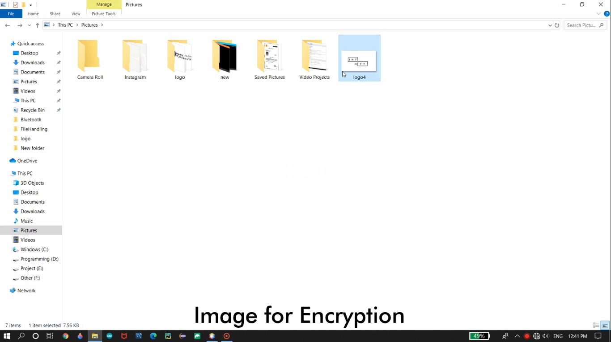

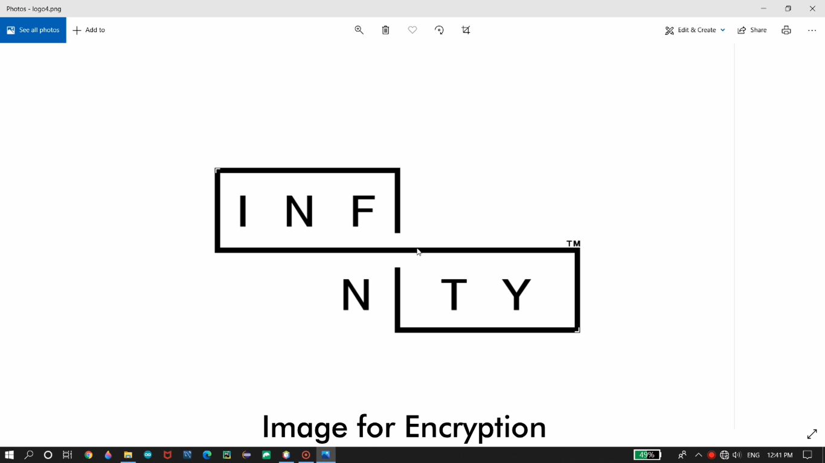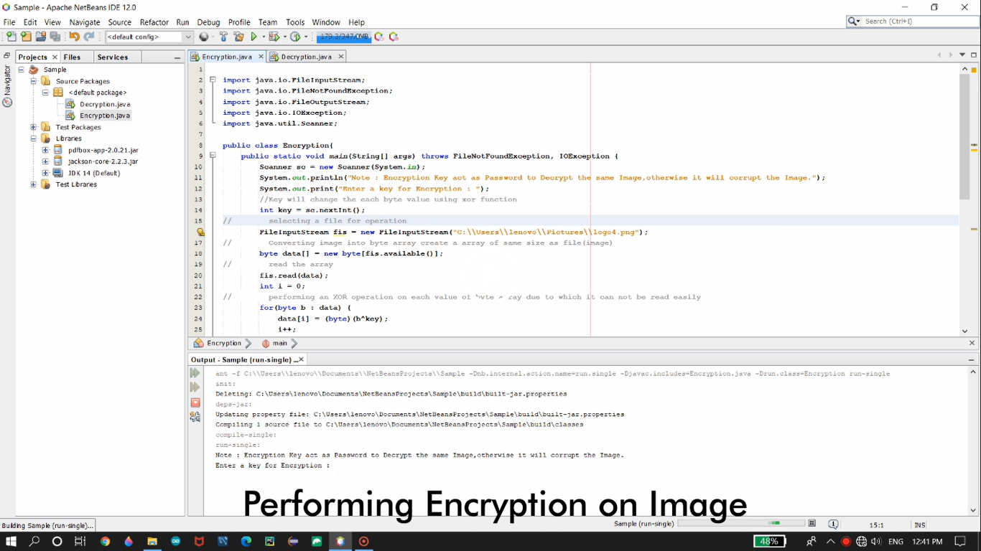

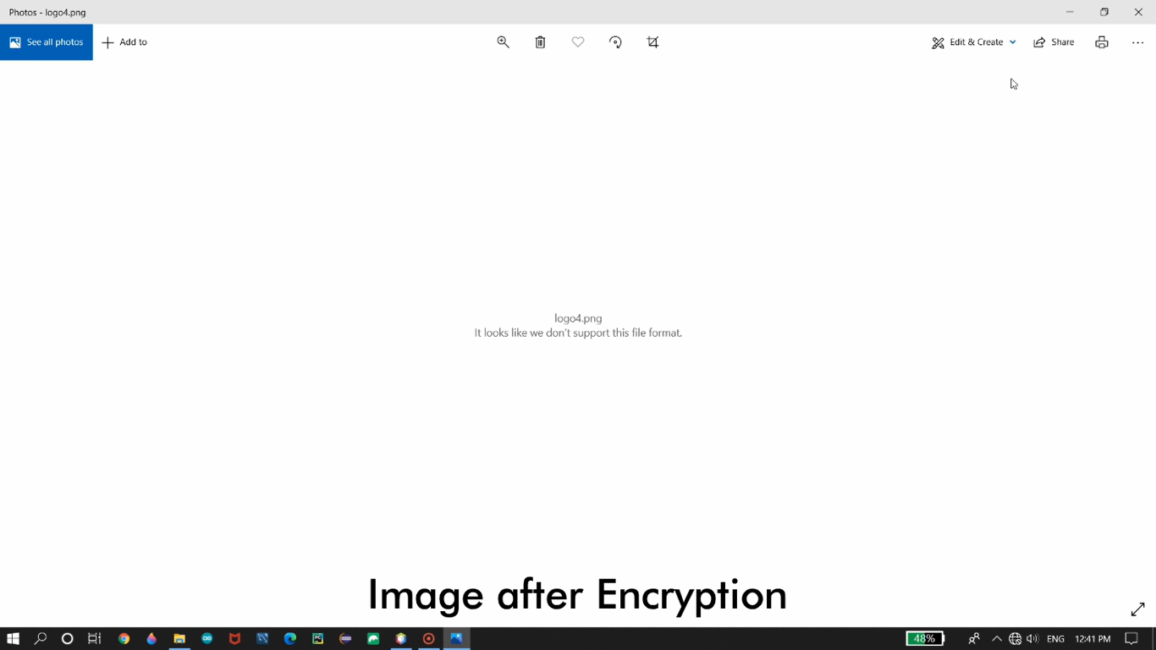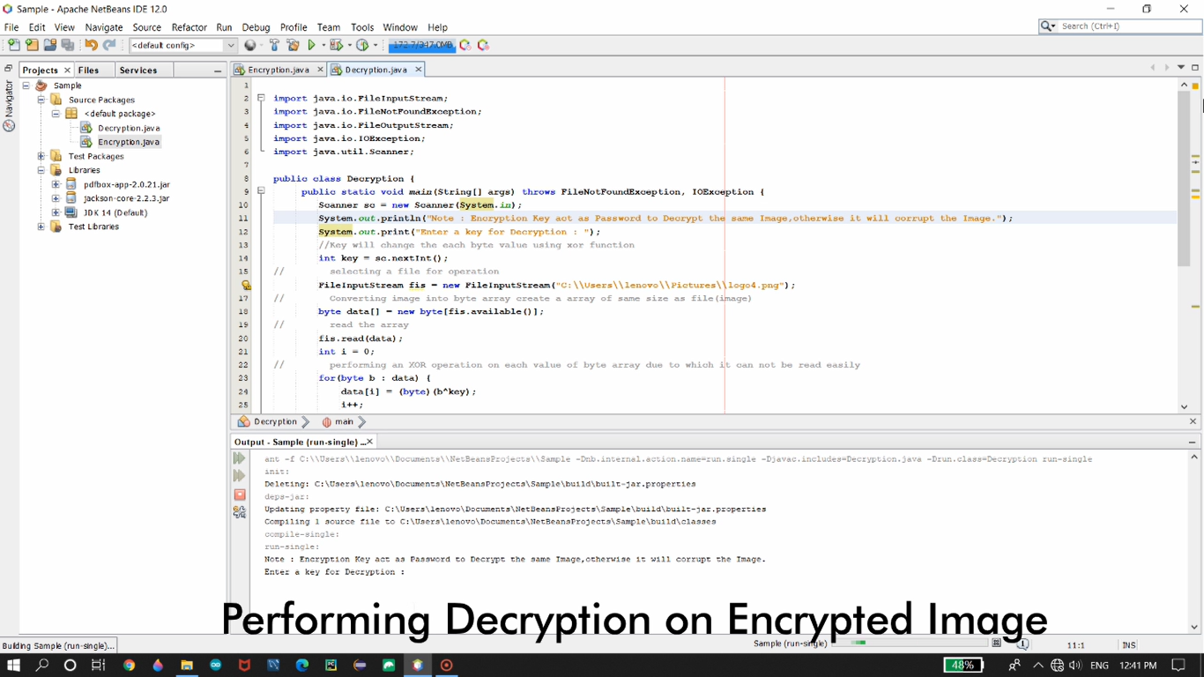

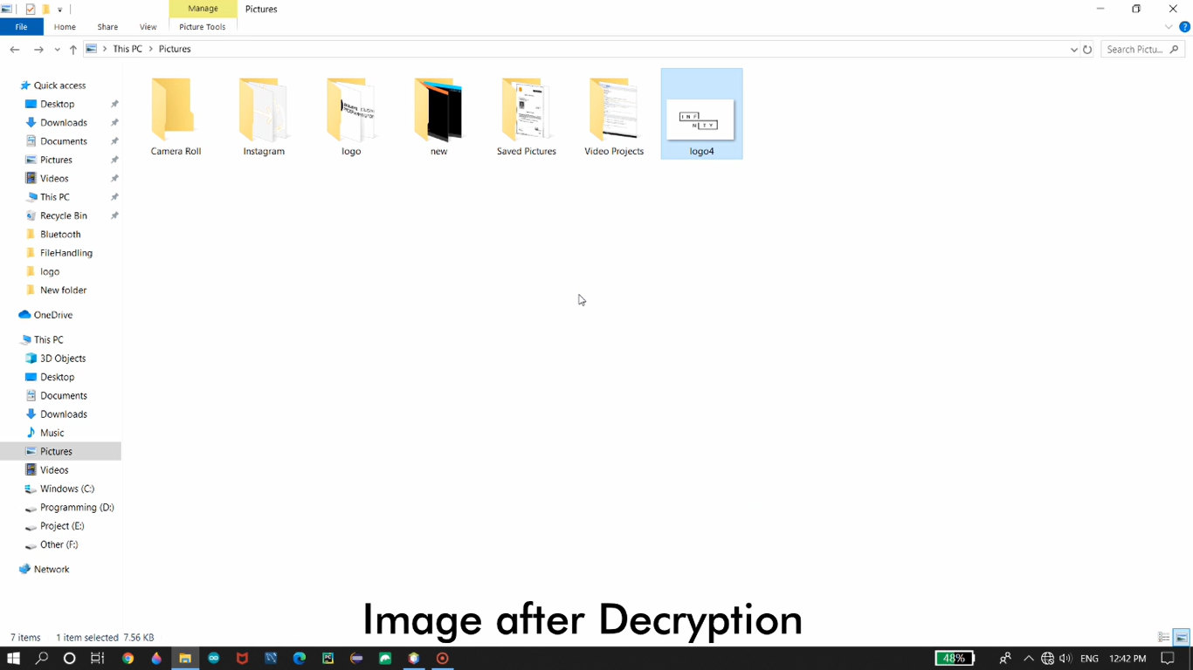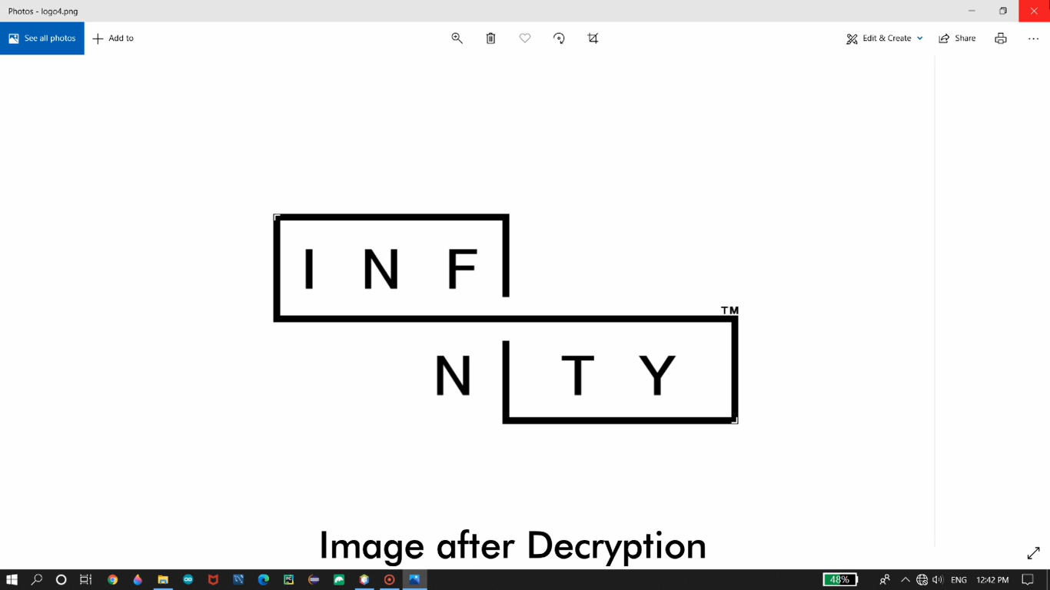

CERTIFICATE

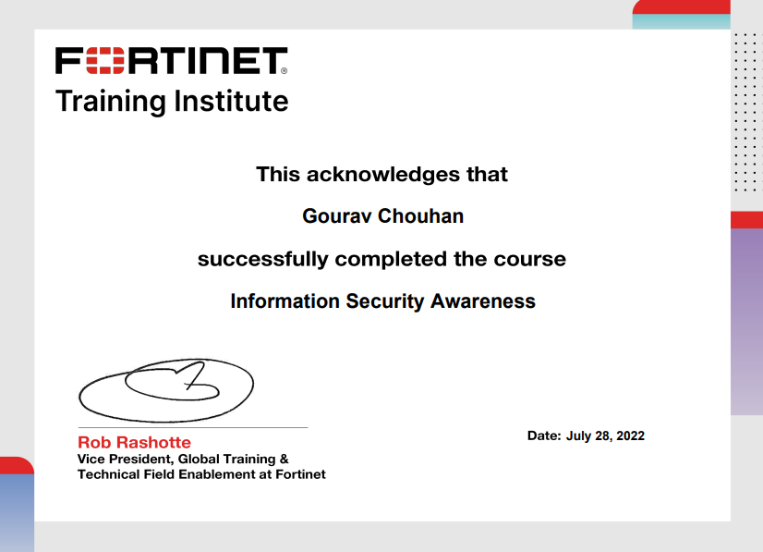

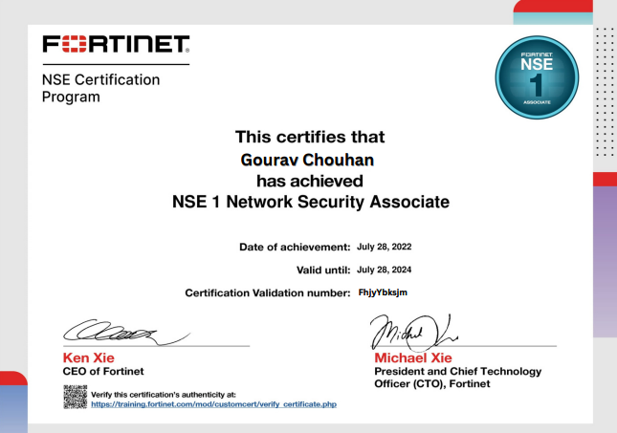

GITHUB LINK:

<https://github.com/gouravchouhan26/Evolution-of-Intership->

CONCLUSION

We are very excited by the vast future possibilities that our project has to offer. Possible improvements include getting back the decrypted image in color. We are also looking forward to encrypt videos by extracting each frame and encrypting the images simultaneously. We know that all the videos have sound. So we are planning to encrypt frames and sound simultaneously. Finally after achieving all of the above, we are planning to create an app which will do all of the above. With two people having the app, one will become the sender and other the receiver at a time, based on the requirements of either of the two. This is future of our project we are looking at and looking forward to implementing all of the above successfully.

REFERENCE

* [www.researchgate.com](http://www.metasploit.com)
* [www.rapid7.com](http://www.rapid7.com)
* [www.security.net](http://www.security.net)
* [www.google.com](http://www.google.com)
* [www.youtube.com](http://www.youtube.com)